**جامعة الأزهر بغزة**

# 

**Tahfeez System**

**نظام التحفيظ**

**By**

**Student Name**

**Khaled Mohammed Nijim**

**&**

**Abed Alfattah S. ALShorafa**

**Supervised by**

**Dr.Khalid M. Ismail**

**10/2022**

# Abstract

(Time New Romans, font size 14, bold B)

(Within one page)

**This Abstract should be written in a paragraph base not as points bases.**

This template is in the correct format - just type over it and save it as your document.

The first item in your thesis should be an abstract of a few short paragraphs (within one page) summarising the thesis.

It is suggested that the abstract be structured as follows:

**Problem:** What you tackled, and why this needed a solution

**Objectives and aims:** What you set out to achieve, and how this addressed the problem

**Methodology:** How you went about solving the problem

**Results:** What you managed to achieve, and how far it meets your objectives.

**Conclusions & Recommendations:** The most important finding (in one or two sentences)

From the abstract, a reader should be able to ascertain if the project is of interest to her/him.

# Dedication

At the outset, we thank God for enabling us and guiding us to complete this work, and we ask Him, the Almighty, to guide us to what He loves and is pleased with.

We dedicate this work to our parents, families and teachers who spared no effort in teaching us and helping us to complete this work. We also dedicate this system to students of knowledge and those working in the field of the Qur’an, asking the Lord Almighty to make it a useful work that pushes students of knowledge towards excellence.

# Acknowledgment

We thank God Almighty, the Possessor of bounty and grace, for having guided us, guided us, and endowed us with the grace of reason to strive for what He loves and is pleasing to Him. We also thank Him Almighty for guiding us and granting us success to this work, for He does not guide us in favor of deeds except Him.

We also thank our parents who planted in us from childhood the love of God, the love of His Messenger, and the love of the Great Qur’an, and they planted in us the seed of incendiary knowledge that blossomed and this work was one of its blessed results. We also thank our families who supported us in this journey and were the best support and help for us.

And let's not forget our teachers who spared no effort in teaching us and helping us to complete this work. We especially mention our virtuous doctor, Dr. Khaled Ismail, for his efforts, patience, and guidance from the start of this work until its completion. We continue to thank the memorization centers and their employees for their contribution to this study and freeing up their time to make this work of interest and benefit what benefits every student and every teacher.

# Table of Contents

(Automatic Table of Contents(

Abstract III

Dedication IV

Acknowledgment V

Table of Contents VI

List of Tables VII

List of Figures VIII

List of Abbreviations IX

Chapter 1 Introduction 10

Chapter 1 Introduction 11

1.1 Problem Statement 11

1.2 Objectives 13

1.2.1 Main Objective 13

1.2.2 Sub Objectives 13

1.3 Scope and Limitations 14

1.4 Importance of the project 15

1.5 Methodology 15

1.6 Tools and equipment 16

1.7 Time Table 17

Chapter 2 Related Works 17

Comparison 19

Chapter 3 Use Case 22

Chapter # Testing and Evaluation 35

Chapter # Conclusions (and/or Recommendations) 36

The Reference List 37

Appendix 1: Information on Appendices 38

# List of Tables

Table (3.2): Alazhar University gaza……………………….

# List of Figures

# List of Abbreviations

|  |  |
| --- | --- |
| **CUT** | Class Under Test |
| **RTS** | Regression Test Selection |
| **SUT** | System Under Test |
| **TDD** | Test Driven Development |
|  |  |
|  |  |
|  |  |
|  |  |
|  |  |
|  |  |
|  |  |
|  |  |
|  |  |
|  |  |
|  |  |
|  |  |
|  |  |
|  |  |

*Note: Sort Alphapiticaly

# Chapter 1 Introduction

(Time New Romans, font size 36, bold B)

# Chapter 1 Introduction

In light of the electronic development and the spread of smart devices everywhere, it has become a duty for all institutions to move from using papers to using computerized systems. One of the most important institutions that must integrate into this intelligent world are the Quran memorization centers. Which will be the focus of our study in this project.

The idea of ​​the project led to a problem facing the memorization centers, which is the great burden on the administration and the governors in preparing and coordinating paperwork and following up on all parties of the center from students, memorizers and parents, as each of them has an important role in the memorization process. Therefore, we found it necessary to develop an integrated system to reduce the burden and increase quality in the centers.

## Problem Statement

The Tahfeez centers face many problems that hinder their educational path in supervising and qualifying the memorizers, following up the students and their achievement, and managing the educational memorization program. And via communication and discussion with the Tahfeez centers consisting of the center’s director, administrator, and memorizers as well as our communication with the students’ families we reached a number of problems that we listed and explained in detail as follows:

1. The workers in the Tahfeez centers face a problem in communicating with the students’ families, as they cannot inform them of their children’s achievement, their weaknesses (whether in terms of memorization or pronunciation) or even send warnings such as warnings of repeated absences, which are sent in the form of a printed paper message. By handing it over to the student's family, hand in hand, and requesting intensification of attention to their children, especially at home, as the majority of parents do not follow up their children continuously in memorizing and learning, even their achievement in Tajweed courses and courses in etiquette, and their daily achievement in memorizing the Holy Quran. The Tahfeez centers also face a problem in communicating with parents who do not have smart phones to communicate with them through social networking applications, and here memorizers need to send regular messages (SMS) on the phone to communicate with the students’ families.
2. The parents of the students complain about the difficulty in following up their children’s daily or weekly achievement in terms of memorizing the Holy Qur’an or training courses, as there is no effective way through which the guardian can follow up his son from home or remotely, and complete what the memorizer started with in terms of education and indoctrination. For his son to memorize and complete his son's education on the etiquette of behavior, good dealings and the etiquette of the mosque.
3. The administrative body consisting of the director of the center, the administrator, and the memorizers faces a problem in conducting statistics on the students of the center, following up on their achievement, recording attendance and absence, as they do all that work and fill out all this data manually and on paper, which increases the burden on them, and this makes this data vulnerable to loss and loss When a record book is lost or worn out and the manually recorded data may be inaccurate.
4. The students’ parents find it very difficult to memorize their children at home and fix what they have memorized in the memorization center, as when they play a YouTube video to teach and teach their children what they will memorize, their children move on to watching other distracting videos and waste a lot of time watching them away from completing memorization.
5. The director of the memorization center faces a problem in following up the presence and absence of memorizers, as some memorizers are absent from the center without excuse, and this causes a big problem in distributing the episodes and completing the work, and the center director cannot appoint a replacement memorizer when the memorizer in charge of the field is absent, as well as communicating with the memorizers effectively away from The system followed, i.e. a face-to-face interview or a relatively expensive phone call, as well as memorizers communicating with the director of the center and informing him of the latest developments and workflow in terms of their commitment to the students and the extent of their achievement, or if they encounter any problem related to memorization.
6. Memorizers face a problem in determining the amount of students’ achievement according to the plan specified for each student, and knowing the weak point in this plan and whether it is suitable for the student or not by following up and evaluating the student according to what he has accomplished in the plan, and doing all this work in paper form and looking at the registration books and that is It is very difficult to do individually for each student and the results are not accurate.
7. The parents of the students face a problem as the memorizer may sometimes not be qualified to memorize and teach students appropriately, or does not find time to teach the student what he should memorize next time, so parents need to see the data and testimonies of the memorizer and enable them to evaluate it themselves by seeing its impact on their children.
8. The reservation centers face difficulty in collecting and financing the centers with the necessary financial support, incentives and prizes for students, and the centers’ supplies such as religious books, stationery, Qurans, and pamphlets dedicated to students’ memorization, and preparing a place designated for courses and memorization, as donations are collected manually from worshipers in the mosque after prayers, which is not sufficient for the needs of the centers. In many cases, worshipers are not prepared to donate when they come to pray, or they prefer to donate in a hidden way through electronic payment methods.
9. Each center, represented by its director, administrators, and memorizers, wants to customize its profile, which distinguishes it from other centers. Choose a picture of the center and a profile about it, presenting the center's mission, goals, services, courses, and its ability to take care of students and memorize them effectively.

## 1.2 Objectives

### 1.2.1 Main Objective

The project aims to create a system that solves the administrative problems facing workers in Quran memorization centers as well as students' families

### 1.2.2 Sub Objectives

1. Make the center's workers able to send notifications to parents through the system and it will be free of charge, so that the governor requests that the notification be sent to all students and the system takes over the rest of the task.
2. The system monitors the student’s attendance in the circle, so that if the student is absent for 3 days (or the period specified by the center director), the system proposes that a warning be sent by the governor to the student’s family, asking him to acknowledge the reading of his son’s absence.
3. The memorized system enables sending a request to intensify interest for the student's family containing the reason for sending the request, and receiving a response from the student's family with interest in the student with the possibility of sending a message with the response.
4. The system shows the students' parents the courses the student is enrolled in with a daily evaluation of the student's activity in the course, with the possibility of downloading the course booklet so that the parents can ask the student and find out the extent of his gain from the course.
5. The system automatically sends a message to the students' parents about the daily achievement at the end of each day, or displays the achievement on the student's page so that the parents can access and review it.
6. The system will provide the ability to send previous notifications in the form of a regular message (SMS) so that the center's workers can communicate with the families of students who do not have smart phones and inform them, for example, of the student's absence or the student's achievement.

## 1.3 Scope and Limitations

The memorization application targets the management of the memorization center in terms of helping them improve the quality of managing and monitoring the centers.

The project may encounter several problems, including:

1. Unavailability of the Internet for users: as the memorization centers do not have the Internet, as well as some parents do not have the Internet permanently because many of them depend on daily cards.
2. The lack of smart phones: Most of the time, those interested in memorizing the Qur’an are poor, and some memorizers and some parents also do not have smart phones on which the application can be run.
3. Lack of computers in the centers: Many memorization centers suffer from the lack of a computer (laptop) in the center, as it will be difficult for them to access the control panel from a mobile phone.
4. The lack of electricity.
5. Users lack of experience in technology: as the application interface will be new to users, and some may face a problem in performing tasks easily because they do not deal with similar applications.

## 1.4 Importance of the project

The application serves a large and very important segment of society, as this category of society does not receive the necessary attention, and the provision of a system to serve this category facilitates its great mission to serve and memorize the Noble Qur’an and improve the quality of memorization, and it also increases people’s interest in this category and exerts effort and money them to be able to complete the memorization of the Koran

## 1.5 Methodology

The incremental model is a software development process where requirements are broken down into multiple self-contained units of the software development cycle. In this model, each unit goes through requirements, design, implementation, and testing phases. Each subsequent version of the module adds functionality to the previous version. The process continues until the system is complete[1].

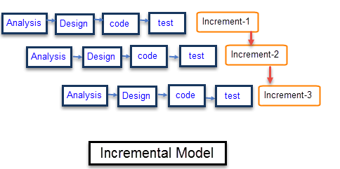

The reason we chose the additive methodology is because the project development schedule is extensive and the requirements are large, because the target group requires a product with important functions to be released quickly and early, and because this methodology enables us to:

* Create priority requirements.
* Errors are easy to spot and easy to test and debug.
* Adaptive risk management is easy because it is managed as it is repeated.

## 1.6 Tools and equipment

For users:

1. A smart phone running Android and a version higher than Android 7.
2. It is preferable that the memorization center have a computer to be able to use the control panel better and with all the features.
3. Microsoft Excel program to be able to open the reports issued by the system.
4. Internet connected on devices connected to the Internet.

For developers:

1. Flutter SDK (version 3)
2. VS code editor or Android Studio IDE
3. Smart phone with Android OS (or Android VM )
4. Internet connection
5. Laptop ( with free space up to 10GB and more than 8GB free on RAM)

## 1.7 Time Table

|  |  |  |  |  |  |  |
| --- | --- | --- | --- | --- | --- | --- |
| 12-2022 | 1-2023 | 2-2023 | 3-2023 | 4-2023 | 5-2023 | 6-2023 |
| ch1 |  |  |  |  |  |  |
|  |  |  |  |  |  |  |
|  | ch2 | |  |  |  |  |
|  |  |  |  |  |  |  |
|  |  |  | ch3 | |  |  |
|  |  |  |  |  |  |  |
|  |  |  |  |  | implementation |  |
|  |  |  |  |  |  |  |
|  |  |  |  |  |  | Testing |

# Chapter 2 Related Works

In fact, there are some systems similar to the system we are working on, but with a different structure, work style, and some pitfalls that make the use not smooth. This is a list of similar systems, noting the difference from our system:

1. Halaqati System[2]: It is a cloud program for managing the Holy Qur’an episodes via the Internet, as the site provides a simple electronic platform for all centers and circle officials to follow up students’ memorization and reviews, and track the absence and attendance of each student, in addition to the possibility of adding notes to students each This is electronically.

Advantages:

* The system operates on a non-directional loop circuit.
* Sending notes, as it sends notes to parents about each student, informing them of the student's level, extent of commitment, and progress.
* Linking the student with the administration, as the program connects the student with the administration and helps parents follow up on their children's progress.
* It is distinguished by a system for following up students by supervisors and memorizers. It provides detailed reports on memorization, revision, progress, grades, attendance and absence.

Defects:

* The difficulty of using the system interfaces due to their complexity.
* Important advantages in a driven system.
* It operates under the circuit system, and this system is not applicable in the local area.
* The difficulty in applying the structure followed in it to the face rings.
* Some errors that appear while using the system.

1. The Ahl-Alquran system[3]: It is an integrated cloud system that was launched in 2020, through which it is possible to create a digital environment that connects the supervisors, students, students and parents of the circles, by giving them modern tools to improve the Qur’an circles:

Advantages:

* The use of the system does not require any skills and it is easy to use, and continuous updates and developments are being followed on the People of the Qur’an system.
* The system is compatible with all devices, systems, browsers, and touch screens, and is equipped with a system of alerts and instant notifications on phones.
* The system allows its users to manage students and teachers, manage circles and e-reading affairs, follow up on memorization, review, reports, manage news and announcements, and go through all the educational and administrative processes.
* Provides the best possible protection for our users' data and privacy, with daily backups of all entered data.

Defects:

* A closed source system.
* Paid in very high amounts for both the student and the center, as such systems are supposed to be free due to the economic situation of both the center and the students.
* The difficulty of linking the system to the old systems to benefit from its information.
* It cannot be played online as it is offline.

1. The ehlquran system[4]: It is an integrated cloud system that was launched in 2020, through which it is possible to create a digital environment that connects the supervisors, students, students and parents of the circles, by giving them modern tools to improve the Qur’an circles:

Advantages:

* The use of the system does not require any skills and it is easy to use, and continuous updates and developments are being followed on the People of the Qur’an system.
* The system is compatible with all devices, systems, browsers, and touch screens, and is equipped with a system of alerts and instant notifications on phones.
* The system allows its users to manage students and teachers, manage circles and e-reading affairs, follow up on memorization, review, reports, manage news and announcements, and go through all the educational and administrative processes.
* Provides the best possible protection for our users' data and privacy, with daily backups of all entered data.

Defects:

* A closed source system.
* Paid in very high amounts for both the student and the center, as such systems are supposed to be free due to the economic situation of both the center and the students.
* The difficulty of linking the system to the old systems to benefit from its information.
* It cannot be played online as it is offline.

# Comparison

|  |  |  |  |  |
| --- | --- | --- | --- | --- |
| Halaqaty | Ehlquran | The ehlquran system | Tahfeez System | System   features |
| ☑ | **☑** | **☑** | **☑** | Student and teacher management |
| ☑ | **☑** | **☑** | **☑** | Circuit management |
| 🗵 | **☑** | **☑** | **☑** | Follow up on memorization and review |
| ☑ | **☑** | **🗵** | **☑** | Device compatibility |
| 🗵 | **☑** | **☑** | **☑** | Ease of use |
| 🗵 | **☑** | **🗵** | **☑** | Security and protection |
| 🗵 | **☑** | **☑** | **☑** | Continuous update |
| 🗵 | **☑** | **🗵** | **☑** | Backup |
| 🗵 | **🗵** | **☑** | **☑** | Free and open source |
| 🗵 | **☑** | **🗵** | **☑** | financial management |
| 🗵 | **🗵** | **🗵** | **☑** | Send scheduled notifications |
| 🗵 | **🗵** | **🗵** | **☑** | Mushaf provides sound and image from within the system |
| 🗵 | **🗵** | **🗵** | **☑** | Conservative evaluation |
| 🗵 | **🗵** | **☑** | **☑** | Send warnings to parents |
| ☑ | **☑** | **☑** | **☑** | reports |
| 🗵 | **☑** | **🗵** | **☑** | News and advertising management |
| 🗵 | **☑** | **🗵** | **🗵** | Electronic reading |
| 🗵 | **☑** | **🗵** | **☑** | Alerts system |
| ☑ | **🗵** | **☑** | **☑** | Send SMS messages |
| 🗵 | **🗵** | **🗵** | **☑** | Managing extracurricular activities |
| 🗵 | **🗵** | **🗵** | **☑** | Fundraising via payment gateway |
| 🗵 | **☑** | **🗵** | **☑** | Conversation (text and audio) |
| 🗵 | **🗵** | **☑** | **☑** | Prepare a plan for each student separately |
|  |  |  |  |  |

# Chapter 3 Use Case

**3.1** **Use case diagram**

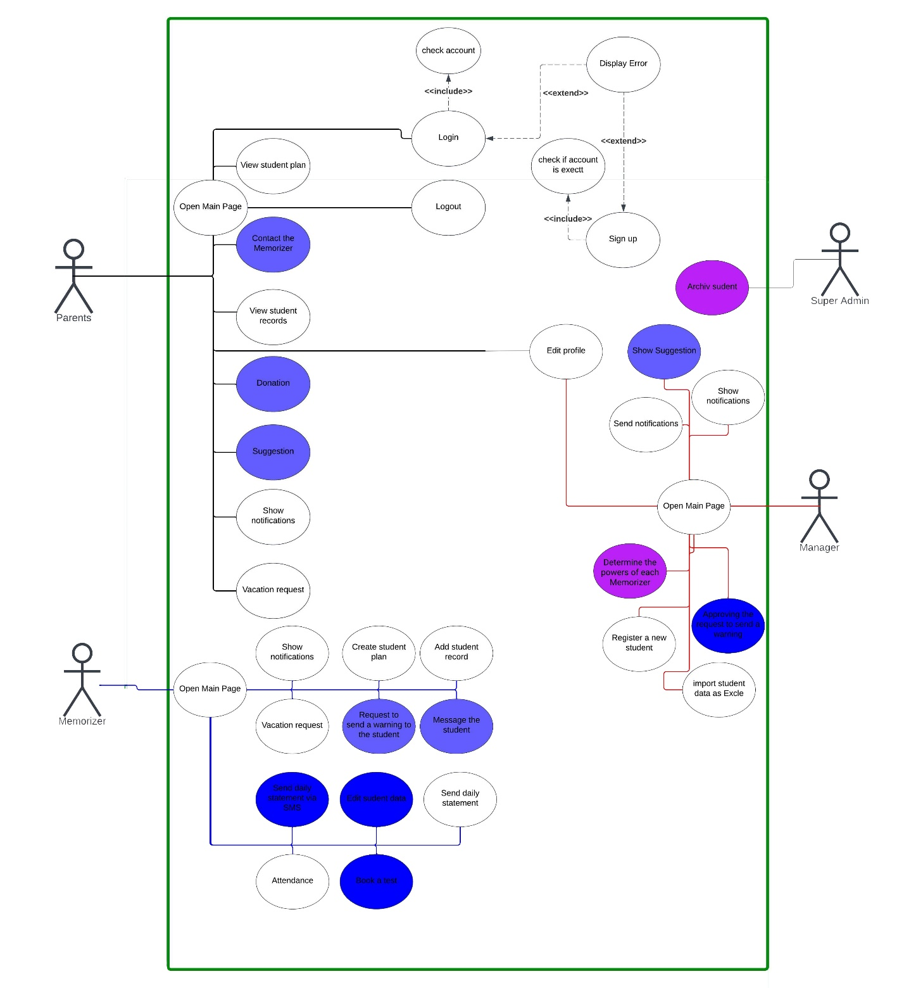

**3.2 Actors**

|  |  |  |
| --- | --- | --- |
| **No.** | **Name** | **Description** |
| **1** | Memorizer | He is the teacher who teaches the students |
| **2** | Manager | He is the person who supervises the center as a whole of students and teachers and manages the center and its resources. He will have full powers in the center. |
| **3** | Super Admin | He is the one who will have powers over all points of the system, he can control even the center managers |
| **4** | Student | He is the person who takes the lessons and recites the memorandum daily, most of the time the student is young and does not have a smart phone; In this case, the parents will be referred to instead in this report |

**3.3** **Use case details**

|  |  |  |
| --- | --- | --- |
| Use-Case Number | UC-001 | |
| Use-Case Name | Edit profile | |
| Priority | Middle | |
| Actor | **Super Admin, Manager, Memorizer, Student** | |
| Description | This use case describes how a user can modify their personal data in their profile within the Tahfeez system. | |
| Precondition | Log in as an authorized user. | |
| Post-condition | If the use case was successful, the actor has now successfully modified their profile. If you do not succeed, no change will be made to the personal profile | |
| Basic course of Action | User Action | System Response |
| 1- The user logs in to his profile and then presses the Modify Profile button.  3- The user modifies the data he wishes to modify, then presses the Save Modifications button. | 2- The system transfers the user to the file modification interface, displaying his data to make modifications to it.  4- The system modifies the user's data in the database and displays the new data in the personal profile. |
| Alternate course of Action | If the user leaves one of the fields blank, the system displays an error message that there is an empty field that must be filled. | |

|  |  |  |
| --- | --- | --- |
| Use-Case Number | UC-002 | |
| Use-Case Name | Send an alarm | |
| Priority | High | |
| Actor | **Super Admin, Manager** | |
| Description | This use case describes how an admin and super manager can Send a warning in the form of a notification that appears on the student’s account, alerting the student of an error “repeated absence, non-completion of assignments, or unwanted behavior. | |
| Precondition | The Memorizer sends a request to send an alert. | |
| Post-condition | If the use case is successful, the user has succeeded Send an alarm in the form of a notification that appears on the requester page. Otherwise, an alarm will not be sent | |
| Basic course of Action | User Action | System Response |
| 2- The manager clicks on the notification, previews the request, and then approves the request | 1- The system sends a notification to the principal with a request to send an alarm to one of the students.  3- The system sends a notification to the student's page, along with the alarm details |
| Alternate course of Action | The manager can reject the request and send the reason for rejection to the wallet. | |

|  |  |  |
| --- | --- | --- |
| Use-Case Number | UC-003 | |
| Use-Case Name | Show notifications | |
| Priority | Middle | |
| Actor | **Super Admin, Manager, Memorizer, Student** | |
| Description | This use case describes how a user can view notifications from the system. | |
| Precondition | Log in as an authorized user in the Tahfeez system. | |
| Post-condition | If the use case is successful, notifications for that user have been shown by the system. | |
| Basic course of Action | User Action | System Response |
| 1- The user clicks on the notification icon from the menu bar. | 2- The system displays notifications for this user. |
| Alternate course of Action | If the system does not display any notifications, this means that the user has no notifications to receive. | |

|  |  |  |
| --- | --- | --- |
| Use-Case Number | **UC-004** | |
| Use-Case Name | Open Main Page | |
| Priority | High | |
| Actor | **Super Admin, Manager, Memorizer, Students** | |
| Description | This use case describes how a user can open their home page in which the Tahfeez system will display each user's personal information, the home page will be the reference for the rest of the system pages. | |
| Precondition | Log in as an authorized user. | |
| Post-condition | If the use case worked, the system showed the home page for each type of user. | |
| Basic course of Action | User Action | System Response |
| 1 - The user clicks on the home page icon from the menu bar. | 1. The system displays the home page for each type of use after Log in .   2- The system displays the unique home page for each type of user. |
| Alternate course of Action |  | |

|  |  |  |
| --- | --- | --- |
| Use-Case Number | UC-005 | |
| Use-Case Name | Add a new user | |
| Priority | High | |
| Actor | **Super Admin, Manager** | |
| Description | This use case describes how a super admin and manager can add a new user. | |
| Precondition | Log in as a super admin and manager. | |
| Post-condition | If the use case is successful, the super admin and manager have successfully added a new user. | |
| Basic course of Action | User Action | System Response |
| 1- The actor selects the list of users from the menu bar, then the new user addition icon.  3- The user fills in the empty fields (ID number, first, second and last name, date of birth, mobile phone, economic status, local area, center, judgment courses, last exam, portfolio, general section and educational stage )and then click the Save Record button. | 2- The system displays a new user addition interface with empty fields.  4- The system adds a new user to the databases. |
| Alternate course of Action |  | |

|  |  |  |
| --- | --- | --- |
| Use-Case Number | UC-006 | |
| Use-Case Name | Import users’ data as Excel | |
| Priority | Middle | |
| Actor | **Super Admin, Manager** | |
| Description | This use case describes how a super admin and manager can import users’ data from an excel file. | |
| Precondition | Log in as a super admin and manager and he has a template for an excel file. | |
| Post-condition | If the use case is successful, successfully imported the user's data from an excel file. | |
| Basic course of Action | User Action | System Response |
| 1. The actor selects the list of users from the menu bar, then the new user addition icon.   3- The user clicks on the Add from Excel button.  5- The user inserts an excel file that contains user data. | 2- The system displays a new user addition interface.  4- The system opens an interface to receive the excel file that contains the data of the users.  6- The system will add all users from the excel file to the database. |
| Alternate course of Action | The system will display an error message if the user exists or the excel file does not follow the specified pattern or is empty. | |

|  |  |  |
| --- | --- | --- |
| Use-Case Number | UC-007 | |
| Use-Case Name | download importing users template file | |
| Priority | Middle | |
| Actor | **Super Admin, Manager** | |
| Description | This use case describes how the super administrator and manager can download a user import template file to be used in use case Import users’ data as Excel. | |
| Precondition | Log in as a super admin and manager. | |
| Post-condition | If the use case is successful, successfully download importing users template file. | |
| Basic course of Action | User Action | System Response |
| 1-The actor selects the list of users from the menu bar, then the new user addition icon.  3- The user clicks on the download template file. | 2- The system displays a new user addition interface.  4- The system downloads the template file. |
| Alternate course of Action |  | |

|  |  |  |
| --- | --- | --- |
| Use-Case Number | UC-008 | |
| Use-Case Name | Login | |
| Priority | High | |
| Actor | Super Admin, Manager, Memorizer, Student | |
| Description | This use case describes how a user can Login to the system to use it's features. | |
| Precondition |  | |
| Post-condition | If the use case is successful, the user will be able to use the system as per their permission. | |
| Basic course of Action | User Action | System Response |
| 1- User opens the system using a link and clicks the Login button.  3- User enter Login username and password in a allocated fields. | 2- System will display login interface.  4- System check data , if true will open Home Page |
| Alternate course of Action | If user inter wrong data in Login page fields, System will display Error message. | |

|  |  |  |
| --- | --- | --- |
| Use-Case Number | UC-009 | |
| Use-Case Name | Logout | |
| Priority | High | |
| Actor | Super Admin, Manager, Memorizer, Student | |
| Description | This use case describes how a user can Logout from the system. | |
| Precondition | It is assumed that the user is already logged in | |
| Post-condition | If the use case is successful, the user will not be able to use the system until Login again. | |
| Basic course of Action | User Action | System Response |
| 1- User click Logout button in menu bar.  3- User click Ok button. | 2- System will display confirmation message.  4- The system will log the user out and take them to the login page |
| Alternate course of Action |  | |

|  |  |  |
| --- | --- | --- |
| Use-Case Number | UC-010 | |
| Use-Case Name | Open Home Page | |
| Priority | High | |
| Actor | Super Admin, Manager, Memorizer, Student | |
| Description | This use case describes how a user can access to Home Page. | |
| Precondition | Login | |
| Post-condition | If the use case is successful, System should transfer user to Home Page depend on his type. | |
| Basic course of Action | User Action | System Response |
| 1- User click system logo, or click Home page from menu bar. | 2- System will transfer user to Home Page. |
| Alternate course of Action |  | |

|  |  |  |
| --- | --- | --- |
| Use-Case Number | UC-011 | |
| Use-Case Name | View Student Records | |
| Priority | High | |
| Actor | Super Admin, Manager, Memorizer, Student | |
| Description | This use case describes how a user can display all records for specific student in system. | |
| Precondition | Login | |
| Post-condition | If the use case is successful, System should display student records. | |
| Basic course of Action | User Action | System Response |
| 1- User click Students from menu bar  3- user click over student name | 2- System will transfer user to Students Page  4- system display student records. |
| Alternate course of Action | For new student, or student doesn't have records, system will display " No Records Available " message. | |

|  |  |  |
| --- | --- | --- |
| Use-Case Number | UC-012 | |
| Use-Case Name | Vacation request | |
| Priority | Middle | |
| Actor | Memorizer, Student | |
| Description | This use case describes how a user can request a vacation from someone higher in the management hierarchy. | |
| Precondition | Login | |
| Post-condition | If the use case is successful, the vacation request will reach the correct user. | |
| Basic course of Action | User Action | System Response |
| 1- User click Request Vacation from menu bar  3- user fill fields for reason and date.  4- user click submit | 2- System will transfer user to Request Vacation Page  4- system send request to right user. |
| Alternate course of Action | If user doesn't fill fields, system should display an alert over the empty fields. | |

|  |  |  |
| --- | --- | --- |
| Use-Case Number | UC-013 | |
| Use-Case Name | Create student plan | |
| Priority | Middle | |
| Actor | Memorizer | |
| Description | This use case describes how a Memorizer can create new plan for each student in his group. | |
| Precondition | Login as Memorizer | |
| Post-condition | If the use case is successful, Plan should be created for selected student. | |
| Basic course of Action | User Action | System Response |
| 1- User click on Student from menu bar.  3- The user hover on the more icon next to the student's name and click create new plan.  5- user Enter period of memorizing, and Surah name and verse number for starting and ending point.  6- user click on submit. | 2- System will transfer user to Student Page.  4- system display Create New Student Plan interface.  7- system create plan based on entered data |
| Alternate course of Action | If Student has finished the entered Surah, system should display error message for Memorizer to change data. | |

|  |  |  |
| --- | --- | --- |
| Use-Case Number | UC-014 | |
| Use-Case Name | View Student Plan | |
| Priority | Middle | |
| Actor | Memorizer, Student | |
| Description | This use case describes how a user can show student plan. | |
| Precondition | Login, Create Student Plan. | |
| Post-condition | If the use case is successful, user should be able to show student plan. | |
| Basic course of Action | User Action | System Response |
| 1- User click Students Plans.  2- user click over student name. | 3- System display student plan. |
| Alternate course of Action | If student doesn't have plan , system should display " No Plan Available " message. | |

# Chapter # Testing and Evaluation

In this chapter, the main results of your work should be presented, together with critical discussion. You may use two different chapters, one for results and another for discussion and recommendation. You need to present all the results (products, experimental findings, theories etc) generated during the project.

Also, you need to describe the degree to which the results support the original objectives laid out for the project. The goals may be partially or fully achieved, or exceeded.

# Chapter # Conclusions (and/or Recommendations)

You can use title Conclusions and Future work. Summarise and analyse what you have achieved.

Also, you could make suggestions for some future works. Explain any limitations in your results and how things might be improved. Discuss how your work might be developed further.

# The Reference List

Indentation (Hanging By 0.63 cm)

This has the following purposes:

1. To acknowledge the source of material being used.
2. To tell the reader where the confirmation of statements that you have made can be found.
3. To tell the reader where a more extensive or more detailed discussion of the subject (or related subject) can be found.

# Appendix 1: Information on Appendices

Appendices may be provided to include further details of results, mathematical derivations, certain illustrative parts of program code (e.g. class interfaces), user documentation, log of project milestones.  In particular, if there are technical details of the work done that might be useful to others who wish to build on this work, but that are not sufficiently important to the project as a whole to justify being discussed in the main body of the thesis, then they should be included as appendices.

There is **no expectation** that the examiners should read the appendices as part of the assessment process.  Hence, it is important that any material which will be significant to judging the quality of the thesis or of the project as a whole should be in the main body of the thesis, and not in appendices.

1. _ <https://www.javatpoint.com/software-engineering-incremental-model>
2. <https://halaqaty.com>
3. <https://ehlquran.com>
4. <https://youtu.be/FYOaNA9NFF4>